HANOI UNVERSITY OF SCIENCE AND TECHNOLOGY

CENTER FOR TRAINING OF EXCELLENT STUDENT
Voice Automatic Detection Algorithm In Speech Recognition System
Student | :NGUYỄN Hữu Hiển
Professor | :Dr. NGUYỄN Quốc Cường

- Introduction About Speech Recognition System
Automatic Speech Recognition – ASR is one of the most important domain, it has been researched widely since decades ago. Generally, ASR refers to recognize the individual word from speech based on a voice corpus, the identification process is based on information contained in the speech signal and on the knowledge about the scope of the domain.
Normally, a speech recognition system consists of two phases: training phase and recognition phase. In training phase, the system will learn standard patterns provided by various sounds (words or phonemes) for building the vocabulary data of the system. Recognition phase or decoder phase will decides the corresponding text base on the vocabulary data.
After sampled, the speech signal features are extracted by a signal-processing module for the recognition process. The features extraction methods commonly used in speech recognition are MFCC (Mel - Frequency scale Cepstral Coefficients) and PLP (Perceptual Linear Prediction). After features are extracted, the feature vector is put into mass recognition, combined with the knowledge of specific linguistic and acoustic characteristics of voice; volume identifier will provide recognition results reasonable. The parameters of the recognition model are gained in the training phase with the training data provided. If the size of the training data is bigger, the recognition ability of the model will be higher.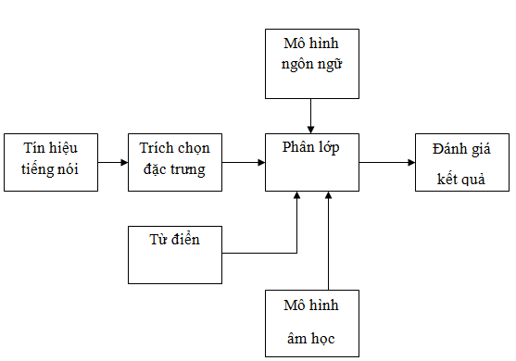
Figure 1: The diagram of speech recognition systems
To facilitate the examination and evaluation of the scheme will divide the speech recognition program into three separate modules:
- Module 1: Conduct the voice signal obtained from the MIC. Then sample voice signal.
- Module 2: Extract the features of the voice signals, which were obtained in Module 1 used MFCC method.
- Module 3: After extracting the features, the features vector is given in recognition module include decoders, acoustic model and language model.
2.THE DIFICULTS ENCOUNTED IN RECOGNIZING THE SOUNDS.
The ideal condition for recognizing the voice in common and recognizing the sound in partical is that the voice would be stable in the trainning time and the recognizing time.One’s voice is unique. Therefore, untill now it is difficult to recognize the voice and the sound.
Until now, It’s not easy to apply the sytem ASR because of some troubles created by the objects of the sytems in this case this is the voice or the sound which is unstable. The troubles are:
- The changes of the voice affected by the time.
- The health of speakers. When one is healthy, he pronouns differently from when he is unhealthy for example he’s got flu.
- The speed of the sound. In a sort of time, the times of pronouncing different sound is different.
Besides, there are some troubles created by the outside reasons:
- The noise from the outside enviroment. For instant, it is easier to listen to someone when he/she speak in a silent enviroment.
- The distance from the mouth of the speakers to Microphone: The further the distance is, the bigger effects it creatives that makes the recognizing incorrect.
- Microphone to record the sound may be different in the different situations.
- THE EFFECTS OF DETECTING VOICE ALGORITHM.
As mentioned above in the components 1.3 , out scene affect directly to 'output result of the recognizing system Regularly, the signals of the voice will be solved before it’s on module to improve quality of the voice. Foresolving includs these following tasks:

➢Removing the diftract background environments (filter the diftract background), removing other diftract backgrounds (the others’ sound,...)
➢ Removing the echo
➢ Removing distance rest, (the sound of hitting on the tables, chairs) distract the signals of the noise in short time.
In this project, I concentrate on presenting the Voice Activity Detection to execute the third task in the module: removing rest time, removing the noise in short time.
The rest time and these noises make the result of the voice recognizing incorrectl because if they occur, the sytem will recognize them as some words in the dictionary.Moreover,this detection will increase the time to recognize the sounds, increasing the time to transfer the sounds (in cases connected sounds in clients – recognizing in the server) because the input signals have been removed unnecessary parts.
- APPLYING DETECTING VOICE ALGORITHM.
4. DETECTING VOICE ALGORITHM ACCORDING TO LTSD.
4.1. ALGORITHM
- This method applyies in the situation that the information essential for detecting the sounds in the unstable environment is the changes according to the time of the amplitude. This method is analised the frame called Long-Term Spectral Envelope ( LTSE )
- The way to determine the catergory the sounds will be successful or not depends on the Long-term spectral divergence – LTSD..
- In Mathematic field, LTSE and LTSD defined as :
o Call x (n) is signals of the voice in unstable environments, x (n) would be catergoried into frames in solving processing.
Call X (k, l) is the amplitude at the band k of Frame l. At that time, LTSE provides N (length of the frame of signals) at band k of will be defined:
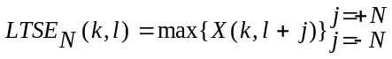(1)
- LTSD at the band N of the first signals frame will be defined: 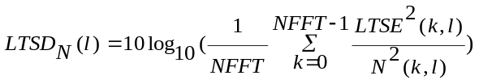
(2)
  - N (k, l) is the average of energy distrbution of the jam which is estimated continuously after each signal frame according the following formula:
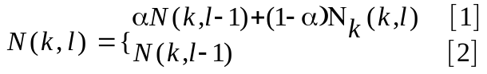 (3)
    - [1] if speech pause is detected
    - [2] otherwise
- LTSD is used as measurement unit for distinguish the voice and the jam. To make known about the role of LTSD, the writers investigate the expression LTSD of signals of the sounds and the jam in the different environments(on the car, at the intersection, etc)
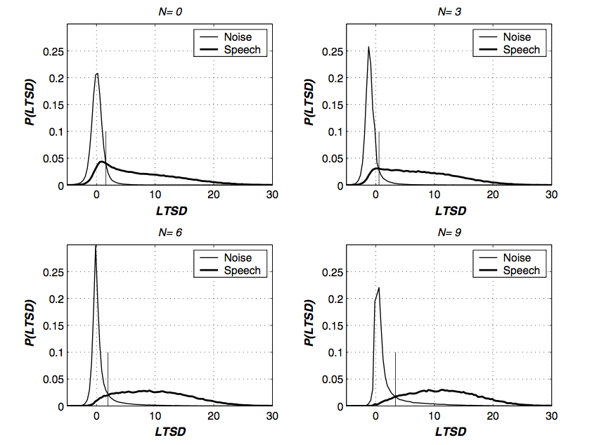
Figure 2: Arranging LTSD accoding to the band N

- Basing on the result, we can see that the higher the N is, the higher arranging LTSD of the voice and the jam is.
- In order to category the voice and the jam background, the values ​​LTSD are estimated at every signals frame and compared with one marked point %.
- The values ​​are estimated based on the mark % for the jam enviroments which has the lowest and the highest energy background E1. The values​​ founded by investigating the real data in the two enviroments above.The estimate formula as follow:
- 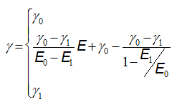 (4)
  - E : Energy of the jam background at the time estimated.
- The particular outline of the formula:
- 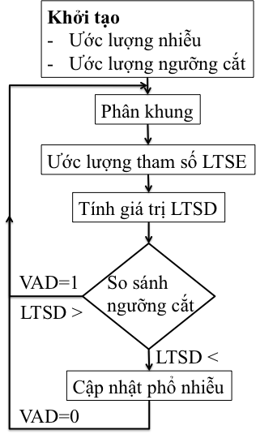
- Figure 3: The outline of formular LTSD

  - STEPS TO DEVEPOPE THE FORMULA
- Step 1: Recording signals of the voice: Using micro of the computer or the phone to record signals with the format: sample frequence 16000 KHz, the number of quantum: 16 bit, type of quantium: signed, mono chanel.
- Step 2: Catogoring the signals:
  - After receiving the signals which were sampled from the micro, start to frame the signals, one includes 400 templates (equivalence 25 ms recording signals).
  - Using frame overlaping with 16 template match per each frame (repeat 1ms after each Frame, the distance between the 2 continuos frames is 384 templates equivalent to 24ms).
- Step 3: Estimate LTSE, LTSD, cut-off band and update noise power.
  - For each frame received, we have to the change to FFT 512 LTSE to estimate 400 LTSE value for that frame.
  - Do not apply the algorithm for the two first frames, 2 frames are considered voiceless. The first 500 samples are used to calculate the initial energy environment for algorithm. Since then calculated for the cut-off band and LTSD of original frames, as the basis for calculating the next frames.
  - Continually update the background of noise energy by the following formula: 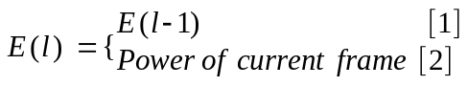 (5)
    - [1]: If the frame found is voice, the energy of the noise energy background equals to the noise energy background of the previous frame.
    - [2]: If the frame found is silence the noise energy background at this time is the average energy of the frame.
  - This formula ensures noise energy background is updated as the environment changes (eg, the speaker moves from quiet environment in noisy environments (street from the meeting))
- Treatment outcomes: After calculating LTSD and the cut-off band for each frame, we can make marked vector on each frame (1 is the voice, the silence 0). Use the marked vector to remove the silence from the original signal into blocks of identification in order to interrupt the recording and send to the server to assess the accuracy of the algorithm.
- 4.3. THE COMPLETED WORKS
4.3.1. VAD offline on PC computer

The application of this program is to receive input 1 audio file of the voice and voiceless, after applying the VAD algorithm will create the new sound file containing only the voice and calculation of the marked file and the accuracy of the algorithm. The application is described as below:
Input: audio wav file storage the voice which has been obtained with the format: Sampling frequency is 16 kHz, the number of quantum bits is 16 bits signed, single channel.
Output:
- Wav file was removed silence.
- Vector frame is marked by voice or not.
The Process:
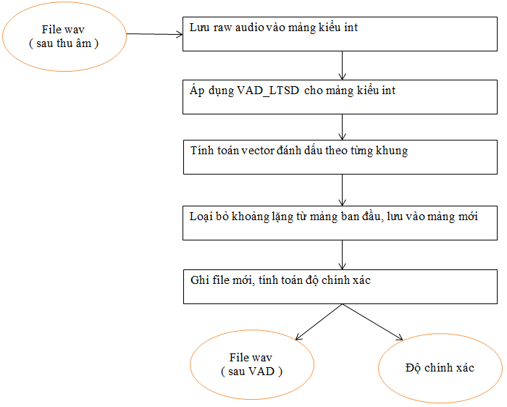
Figure 4: The outline to apply VAD offlline for PC computer.
Use audio signal (raw audio) (has to be sampled) from the original wav file and save to an array of ints.
Applied VAD algorithm on raw array audio above (VAD application details are presented in Section 2.3.
- Calculate vector markedup voice or voices for each frame.
- From marking vector and original raw array audio, the frame is removed the silence array and kept the voice frame in a different array of ints.
- Record after VAD files from an int array and calculate the accuracy of the algorithm (presented in detail in section 3.4.4)
4.3.2 VAD online on PC computer
The application of this program was recorded by both the PC microphone and VAD algorithm applied to the audio stream, when the user does not say (creating silence) over a preset period of time determined (from 1.5 to 2 seconds) the program will automatically interrupt the recording.
With the audio stream received until the break, the program will perform VAD then put into a queue to record or file can be sent to the identity server. The application is directly described below:
- Input: Audio recording from microphone of the PC
- Output: Wav files were removed array silence or the voice was removed the silence to send to the indentify server.
- Arrays which are marked by frames are voice or not. The process:
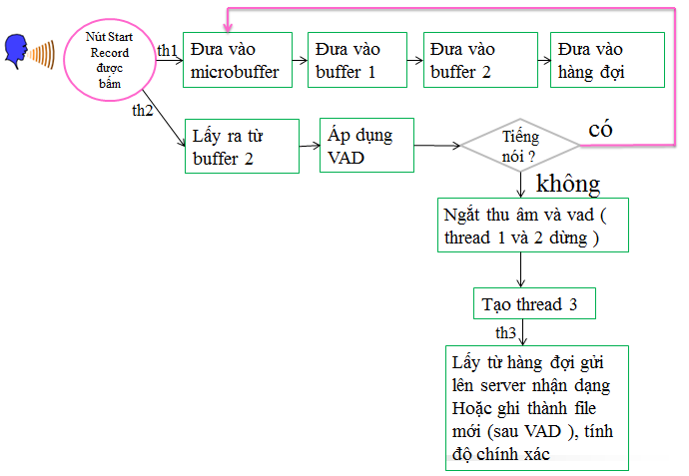
Figure 4: The process of application of VAD online for PC computer.
When you press the record button on the interface, the program created 2 threads:
Thread 1
    - Record, store samples from the microphone buffer to the buffer program.
    - Save the template in a queue (for sending to the server later)
  - Thread 2
    - Get a buffer from the program, use the VAD method to automatically record break the record.
- When we interrupt the recording (break automatically depending on the results of the thread 2) creating thread 3 programs:
  - VAD samples from the queue and writes to a file
  - Or send to the server identity
4.3.3 Applying VAD for Android
The application of this program is recording an Android device with microphone (phone, tab, ...), at the same time applying VAD algorithm to the audio stream. When the user does not say (creating silence) over a preset interval determined time (from 1.5 to 2 seconds) the program will automatically interrupt the recording. The audio stream received will be sent to the server to identify and recognize the results text from the server identity, then displayed on the screen. Users continue to press the record button to say the next sentence and wait recognition results on the screen. Application is directly described below:
Input: Audio recording from the phone's microphone or tab
Output: array of voice to send to the server
The Process:
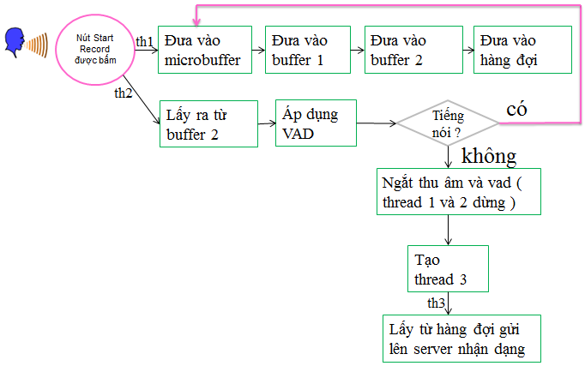
Figure 5: The process of applying VAD for Android.

- When you press the record button on the screen, the program creates two parallel threads:
  - Thread 1
    - Record, put the audio signal into the microphone buffer (microbuffer),
    - Put the audio in the program buffers (buffer 1)
    - Put the audio into buffer 2 in order to the thread 2 can retrieve and apply VAD (this buffer is used to avoid concurrency structure which is supported by Java (using Array Blocking Queue structure with dimensions of 8000, we put it into buffer 2 if the buffer is not full and remove it when the buffer is not empty)
    - Take on the queue to interrupt recording and then send it to the identity server.
  - Thread 2
    - Taking the audio from the buffer 2 8000 samples per time.
    - Apply VAD algorithm to decide to interrupt or not interrupt the recording .
- When interrupt recording (self breaker depending on the results of the thread 2) program will take the form of queue up to a short array and sent to the server and then wait for identification results from the server . Afterreceiving results from the server, identification program will display the results on the main interface of the UI thread.
- After the results shown, the record button is enabled. Users continuously press the record button on the next time: talking and waiting recognition results. 4.3.4. VAD on identify server
The application of this program is to identify the blocks on the server an independent modules to perform VAD and help remove the silence and pulse audio is not speech then make recognition results more accurate and speed of identification faster. The pairing will be described in detail in Chapter 4. Here are the features of this application:
The apperance of this module depends on the require of the programmer.
- Be independent from Sphinx 4 on server
- Be in front of recognition module Sphinx 4
- Inputs, outputs, implementation process are similar to 3.3.1 (VAD offline on PC)
  - Input: the original audio wav file
  - o Output: wav files with voice segments are connected together .
  - Implementation: Take samples from the original wav file and put into an array, apply VAD algorithm to the array and record to a new wav file.
4.3.4. Estimate the accurac of algorithm LTSD
Within the framework of my thesis, I evaluated the algorithm for the offline PC case because of the favorable conditions of hardware, software and especially the Java programming on PC makes it easy to test results .
To be able to assess the accuracy of the algorithm, we need the following conditions:
- Having recorded the original file with methods to observe and signals labeled as a basis for comparison.
- Creating the original checked out array.
- Create the array of file marks after applying the algorithm
- There are methods to quantify the accuracy
The problems and requirements above are presented in detail in the following sections:
The steps :
- Be recorded by a program written in java on PC
- Observe the original signal spectrum and labeled with Audacity software
  - 1: voice
  - 0: voiceless
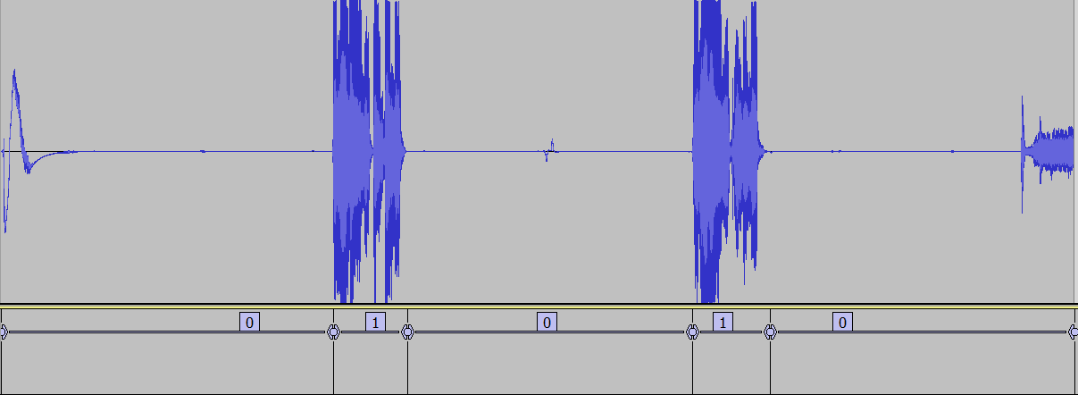
Figure 6: Label the intermittent file record
After labeling, we will have txt file as input of another java program to create an initially marked array .
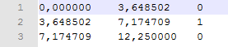
Figure 7: txt file after labeling.
- Applying VAD algorithm initially will creates marked arrays later .
- From 2 arrays, we can calculated the accuracy parameters measurement by another program in java.
- After the VAD, we record new wav files (leave gaps) to facilitate the examination and make the results table.
- The input parameters are computed based on the actual conditions. The parameter includes:
- E0: noise energy background with the least noise.
- E1: noise energy background with the most noise.
- Threshold_0: cut-off corresponding to the least noise environment.
- ➢ Threshold_1: cut-off corresponding to the most noise environment.
- The lines on a distribution frame after frame
- Overlap: the distance between 2 continuous frames
- Alpha: updated noise environment coefficients.
- The use of the next frames.
The following are the values ​​of the above parameters:
➢ E0: (in 10 * log10 (power of the least noise environment)) 6.02
➢ E1: (in 10 * log10 (power of the most noise environment)) 85
- Threshold_0: 35
- Threshold_1: 20
- Sub-frame: the model on a frame: 400
- Overlap: the distance between two consecutive frames: 384 samples
- Alpha: 0.7
- The use of adjacent frames: 9
Using the method of ROC (Receiver operating characteristic) to evaluate the accuracy of the algorithm.
Calculated parameters for the accuracy of the algorithm (in one program written in java)
- Tpr: true positive rate
- Fpr : false positive rate
- Acc: accuracy ( độ chính xác )
Evaluation results: With 14 wav file recording through the microphone of the laptop, the evaluation results of the VAD algorithm are as follows:
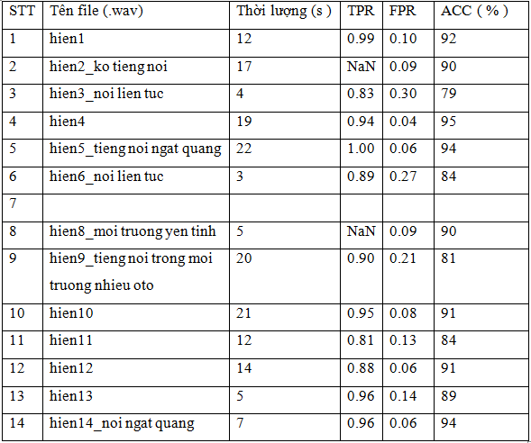Figure 8: the evaluation results of the LSTD algorithm

5. CONNECTION WITH IDENTIFICATION MODULE
A speech recognition system usually has two major modules: preprocessing and recognition. We can combine two modules into a common block and install on the same hardware. However, this task is more difficult for two independent modules.
For large systems, the identification module is usually placed on the server and preprocessing is put on client. It really helps us to develop and improve the quality of each module independently. But the important question to be posed is how to connected client - server between 2 modules effectively?
In this part, I focus on describing the connection between the client, the recording program on your PC or Android device to run on a Windows server identity or Linux 4 is using Sphinx speech recognition engine for the system identification system for medium and large dictionaries. This module has been deployed by Nguyen Thanh Tung and installed on the server. Besides, I also make assessments on transfer time, recognition time and resources required to identification module on the server.
5.1. THE OUTLINE
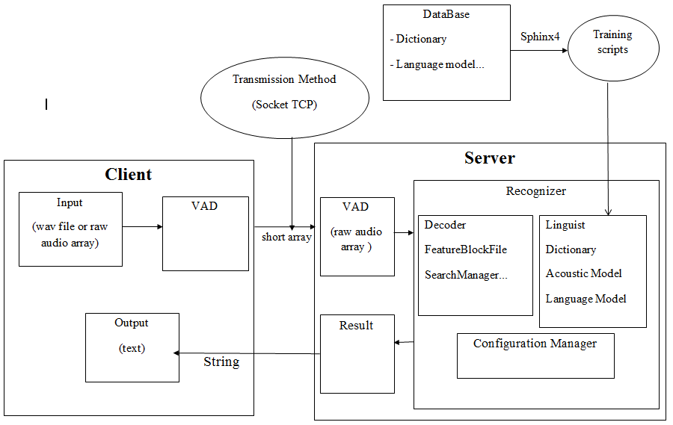

Figure 9: Hình 9: The outline of connecting client-server of recognization system.
5.2. HOW TO WORK
Environmental communication network is: Internet (wired network, 3G), LAN (wired network, wifi)
Connection Type: Multi Client – Server
- Client sends the server a short array audio signals were sampled
- Server recognize and return results as text.
- Mode of transmission: TCP Socket
The way the whole system works Multi client - server speech recognition is described as follow :
After recording in the client, the client will automatically interrupt the recording and open socket connection to the server, the original voice samples were cast from int to short and short is stored in an array and are sent to the server for the entire sending speed.
When the server runs, we have to open the socket to listen and connect when a client wants to connect. With each client , the server create a separate thread to response to the client:
- Get short array that client send to
- Convert short array into int array
- VAD int array to remove the silence and short sound pulses
- Recorded wav format sound files as input for identify blocks.
- Identify audio file and returns the result as a string
- Send the string to the client
- Close the connection with the client and the corresponding and end the thread.
Because each thread on the server is characterized by its own socket correspond so server always ensure the right to receiving and payment to the correct client.
When the server startup, it will create parallelly 3 regconizers with 3 decoders. In each of recognizer, it has VAD modules and identify modules using Sphinx 4. The first three requirements in turn are classified into 3 sets recognizer order 1, 2, 3. Every time a regconizer received the require from a client, it will turn busy flag. And after identification finished flag will pop free. A recognizer will have a variable measuring the leisure time. Since the 4th request from the client, the audio data received from the client will be assigned to the regconizer are free and have the greatest free time.
5.3. PROBLEMS ENCOUNTED AND SOLUTIONS
Save server resources: 1 recognizer for all clients → waiting time of large client.
Reduce the waiting time of the client: create multiple reconizers which work parallelly with the same data → there will be wastage of resources (with the identifier but do not need to initialize) → Need balance between 2 criterias.
Preliminary calculations:

- In the 10s has about 100 client connections → with 100 audio files to transfer.
- Identification Time ≈ 0.5 s → total identification time ≈ 50s.
- To meet the needs of the identification within 10s = 50: 10 = 5 sets
5.4. RATING THE RECEIVE SPEED OF CLIENT-SERVER
Speed ​​of sending and receiving client - server depends on:
Tốc độ gửi nhận client – server phụ thuộc vào
Communication Environment: Lan, 3g, Internet
Use of data: The bigger the data is, the more time it accounts to send the data.
Below is the assessment results table :
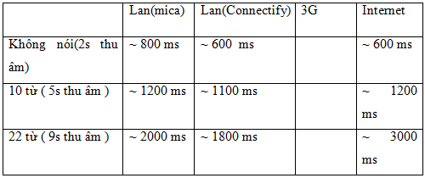
Figure 10: Speed ​​of sending and receiving client - server Because that once someone say and interact the device, it takes no more than 10 seconds with the number of words no more than 22 words so the time to wait and get the results from 0.5 to 3 seconds. It is acceptable for the interacts directly voice application.
- CONCLUSION
Within 6 weeks internshiping at research institutes and 15 weeks working Mica projects under the guidance of Dr. Nguyen Quoc Cuong and the enthusiastic help of the teachers, friends at academics Mica, my project has completed the following tasks:
- Studying the general knowledge about the speech recognition system and giving the difficulties encountered in a speech recognition system
- Learn the voice detection algorithm typically ranging from simple to complex
- Apply one of the best current algorithm is VAD_LTSD to eliminate gaps, eliminate the short pulse which is not the voice on your PC and Android devices to help correct recognition results and increase the transmission rate recognition, identification speed.
- Provide the method of updating the noise background environment to help the algorithm better adapted to the changes of the environment.
- Review the accuracy of the algorithm, the average is 90%, this is the good result, acceptable for the detection module for voice recognition system.
- Connect the two independent modules: pre-processing on the client and server to identify multiclients-way server. Since then , it allows to develop and improve the quality of each module that guarantees connectivity of the system.
However, with limited time and limited knowledge the projects still exist the following limitations:
- Sometimes it makes mistake when it distinguish voice and voiceless.
- Having no way to check the communications from client to server.
- The client-server transfers are sometimes slow (depends on network)
The reasons for these restrictions, mainly due to the following reasons:
- The input parameters of the voice detection algorithm (include: noise background energy of the lowest-noise environment: noise background energy of the most noise environments:, the cut-off of the lowest-noise environment: Threshold_0 and the cut off of the highest-noise environment: Threshold_1) is not optimal.
- The nature of the LTSD algorithm.
- The transfers were not the best. It uncompressed data.
REFERENCES
[1]http://www.clear.rice.edu/elec532/PROJECTS98/speech/cepstrum/cepstrum.html
[2] LSA 352 Speech Recognition and Synthesis - Dan Jurafsky
[3] Separation of Voiced and Unvoiced using Zero crossing rate and Energy of the Speech Signal - Bachu R.G., Kopparthi S., Adapa B., Barkana B.D. - Electrical Engineering Department School of Engineering, University of Bridgeport
[4] A New Adaptive Long-Term Spectral Estimation Voice Activity Detector-Javier Ram´ırez, Jos´e C. Segura, Carmen Ben´ıtez, Angel de la Torre, Antonio Rubio-Department of Electronics and Computer Technology-University of Granada, Spain 2003
[5] Introduction Basics of signal processing-Pr. Eric Castelli-January 2013
[6] Analysis of Speech signal – Pr.Eric Castelli-February, 2013
[7] Noise Robust Voice Activity Detection-Pham Chau Khoa-School of Computer Engineering – Nanyang Technological University
[8] Tiểu luận: Tìm hiểu phương pháp phân tích đặc trưng tiếng nói – Nguyễn Ngọc Đăng – 2010
[9] Xử lý tín hiệu-GS.TS Phạm Thị Ngọc Yến-NXB Khoa Học Kĩ Thuật.

